Team Dragonicorns - Game project "SPOOKS"

Written by Nicolas Labonte, 2013-07-18

- Game Concept;

The player is an asylum patient who got there because of his clown phobia. One night he wakes up and starts seing dead clowns. He then wants to get out and looks for an exit. He searches for keys to get to the 3rd floor where he could easily escape. Meanwhile, an evil, dead clown is looking for him. The player carries a flashlight that he has to recharge by mashing the " R " button. He also has the ability to run, by pressing LeftShift, for a limited amount of time due to its limited stamina. Its stamina can be recharged by walking or waiting. You walk with WASD.

- Gameplay Mechanics;

The player will have a rechargable flashlight and a running and stamina system. The challenge will be to escape by findings keys and the matching locked areas. Also, the dead clown enemy will be chasing the player and the player dies instantly on contact with the enemy. The player will be challenge mentally while his sanity is being put to the test.

- Level Design

The objective is to collect keys to unlock areas and progress. The player has to get to the 3rd floor that way in order to escape, while the dead clown tried to kill him. The floor plan will follow. The Rythm curse is almost impossible to determinate because the game enemy positions and the spooks are random.

Floor Plan - Floor 01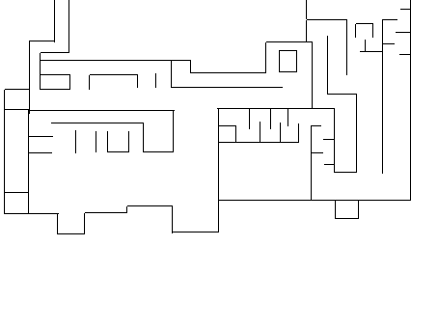

Floor 02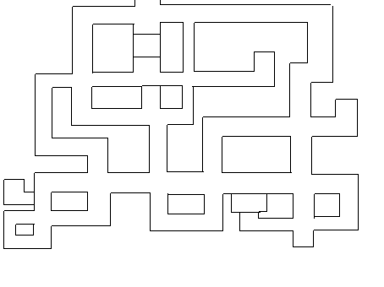

Floor 03